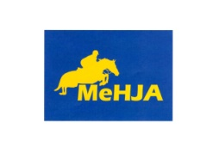
Maine Hunter/Jumper Association
Application for Downeast Medal Finals Scholarship
Criteria for consideration of award:
- Must be a MeHJA member
- Must be qualified for Downeast Medal Finals (DMF)
- Must demonstrate financial need
Winner of Scholarship receives $250 to attend the Downeast Medal Finals. Winner will be announced August 20th.
To apply, qualified rider must submit this form with an essay of no more than 500 words to include why they want to attend finals. In addition, applicant must submit 3 references (one from their trainer) to demonstrate need and desire to attend DMF.
Name: _____________________________________________________________
Address: ___________________________________________________________
Age: _________________ Division Qualified for: _______________________
Trainer: ____________________________________________________________
Parent (s):__________________________________________________________

By signing the form below, I testify that all information I submit is true to the best of my knowledge.

Applicant Signature:______________________________________________________
Parent signature (if under 18 years old):______________________________________

Please submit all information (this application, essay and references) before August 15th to:
Wendy McCann
64 Witham Rd
Auburn, ME 04210

