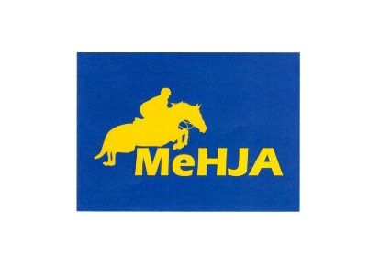

Maine Hunter Jumper Association
Sponsorship Application for
MeHJA Summer Classic July 8, 2018

Name of Sponsor: _______________________________________________________________
Address: ______________________________________________________________________
Phone #: _____________________________________________________________________

Type of Sponsorship:

Single Class Division
$30 $50
Honorable Mention
$15

Name of Class or Division: ________________________________________________________
Name of Class or Division: ________________________________________________________
Or Let MeHJA Choose: __________________________________________________________
Name of Sponsor (as it should be announced/printed): _____________________________________
Total Sponsorship Amount Enclosed: $ _________

Hosting this event would not be possible without your continued support. We thank you very much and look forward to seeing you on July 8th!

Checks can be out to Maine Hunter Jumper Association (MeHJA) and mailed by July 1st to:
MeHJA
c/o Wendy McCann
64 Witham Rd
Auburn, ME 04210

